# **MS Project Mid-Semester Progress Report**

<*Enter your details below*>

Student Name:

ERP ID:

Title of Thesis:

Supervisor’s Name:

Signature of Supervisor:

Date:

Instructions:

* This mid-semester progress report for MS Project carries 45% weightage of your total MS Project grade.
* You will submit the PDF of this report on LMS by the set deadline.
* Remember that the report must be signed by your supervisor. Otherwise, it will not be acceptable.
* The deadline will be announced by the MS coordinator. No late submissions are acceptable.
* Do not exceed the required length of each section
* On using images and tables from other sources, cite their source as well.
* The total length of this report should be a minimum of 6 pages and a maximum of 12 pages.
* Explanatory notes have been added in each section for your assistance. Follow these notes strictly regarding the requirements of each section. Not complying with the requirements will lead to the rejection of the report
* The final document should not contain any explanatory notes.
* The basic purpose of the MS Project is to address some current need of the industry in a way which has not been solved previously before. Your solution should be concrete with a robust design, market positioning and thorough implementation.
* A low-level solution or something which has already been implemented will lead to a rejection of the report.

Section 1: Introduce the Business Domain:

*[Section length: At least 2 medium-sized paragraphs]*

In this section:

* Introduce and briefly describe the business domain, e.g., Fintech, Islamic banking, patient treatment, medical insurance, supply chain, cryptocurrency, cloud computing, smart cities, learning management systems, real estate, travel etc.
* You should describe **all** state of the art information about your domain

Section 2: Describe the Business Process:

*[Section length: Maximum 2-3 medium-sized paragraphs]*

In this section:

* Describe the exact business process related to your business domain for which you will be developing the project.
* Examples: fraud detection, risk-sharing financial agreements, clinical surgery scheduling, patient diagnosis, demand forecasting, autoscaling and load balancing on the cloud

Section 3: Describe the Business Problem to be Solved in this Project

*[Section length: Maximum 2-3 medium-sized paragraphs]*

In this section:

* Describe the exact business problem related to your business process
* Examples:
  + Unpredictable user demand causes service downtime requiring a novel solution for cloud load balancing,
  + Inaccurate demand forecasting leads to stock pile-ups and stock-outs hence wasting money,
  + Clinical surgery schedules are unoptimized leading to unused surgery rooms and doctor dissatisfaction,
  + No effective framework for risk-sharing assessment in Islamic banking leading to customer dissatisfaction

Section 4: Enlist and Describe Already Existing Competitor Solutions

*[Section length: Maximum 2-3 medium-sized paragraphs]*

In this section:

* Mention which are your competitor products which are already available on the market.
* The competitor products can be local or international – give references to websites or mobile apps or even research articles if applicable – you can provide comparison in a table (recommended).
* This section must be thoroughly executed.

Section 5: Justify the Uniqueness of your Solution

*[Section length: Maximum 1-2 medium-sized paragraphs]*

In this section:

* Inform how your proposed project solution is going to be different from the competitor products in Section 4.
* The differences must be crystal clear.

Section 6: Requirements Document:

*[Section length: Maximum 2 medium-sized paragraphs]*

*In this section:*

* *Mention the functional and non-functional requirements as a bulleted list*
* *Create a project on* [*Trello*](https://trello.com/)*, and put all requirements there to show their progress regularly*
* *Mention the Trello link*

Section 7: Design Diagram:

*[Section length: Maximum 2 medium-sized paragraphs]*

In this section:

* Illustrate and explain the design diagram of your proposed project, e.g., the sequence of steps of a process, or the modules of a software
* The design diagram should be professionally done – follow standard software design practices.

Section 8: Use Case Diagram:

*[Section length: Maximum 2 medium-sized paragraphs]*

In this section:

* Illustrate your use case diagram - How to make a use-case diagram is explained [here](https://www.youtube.com/watch?v=zid-MVo7M-E).
* This diagram should encompass all the functional requirements for your proposed solution.
* How a sample use-case may be written is shown in the following diagram:

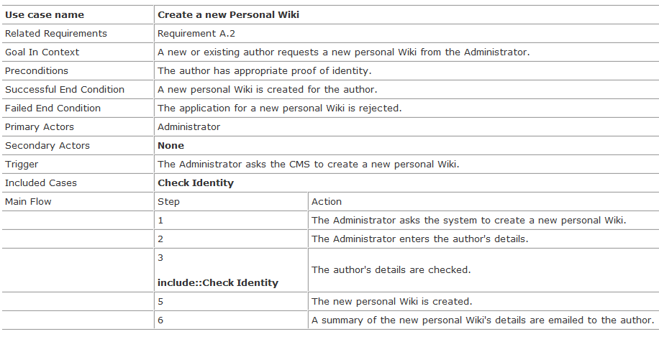

Section 9: Development Path:

*[Section length: Maximum 2 medium-sized paragraphs]*

*In this section:*

* *List all potential APIs, tools, programming environment, software etc. to be used in implementation of your project*
* *List the expected limitations of your proposed solution*

References (if applicable, make a bulleted list):

*Some facts:*

* *Use Harvard reference style as above*
* *Use Mendeley (Mendeley Cite for Word) to manage references (as done above)–* 
  + *First download Mendeley reference manager and Mendeley cite plugin*
  + *Open manager and create a new collection*
  + *Add your articles to this collection (which you want to cite in this report) – you can add Bibtex entries, PDFs etc. related to your article.*
  + *In References tab, open Mendeley Cite – your collection will appear*
  + *In Citation settings, set the referencing style as Elsevier Harvard (without titles)*
  + *Add articles from the collection into your document wherever you want*
  + *When you have finished, then click the three-dots in Mendeley Cite and Insert Bibliography at the end of the document (like above)*