MS Project Mid-Semester Progress Report

Name of Student:
ERP:
Title of Project:
Supervisor’s Name:
(Digital) Signature of Supervisor:
Date:

Instructions: This mid-semester progress report carries 30% weightage of your total MS Project grade. Provide concrete information and keep the length of your responses within the required limits. Your supervisor will email the PDF of this form to Ayaz (mayaz@iba.edu.pk) and Saad (saadkhan@iba.edu.pk) (PO office) and myself (tmahmood@iba.edu.pk) with your supervisor in cc. Deadline for this form’s submission will be informed by the MS coordinator (Dr. Tariq Mahmood). No late submissions are acceptable for any submission deadline in MSCS and MSDS programs.

Problem being solved in the Project: (e.g., developing a product/framework/methodology to recognize a particular identity card, facilitate E-commerce customers in choosing their desired product, implement core data governance functions etc.) [1-2 paragraphs]

Requirements Document: (Mention the functional and non-functional requirements as a bulleted list - create a project on Trello, and put all requirements there to show their progress regularly).

Comparison with Competitor Solutions: (which are your competitor products which are already available on the market and how does your product differ from them? The competitor products can be local or international – give references to websites if applicable – you can provide comparison in a table if feasible) [1-2 paragraphs]

Design Diagram: (Illustrate and explain the design diagram of your proposed project, e.g., the sequence of steps of a process, or the modules of a software)

Use Case Diagram: (illustrate your use case diagram. How to make a use-case diagram is explained here. This diagram should encompass all the functional requirements for the software).
How a sample use-case may be written is shown in the following diagram:
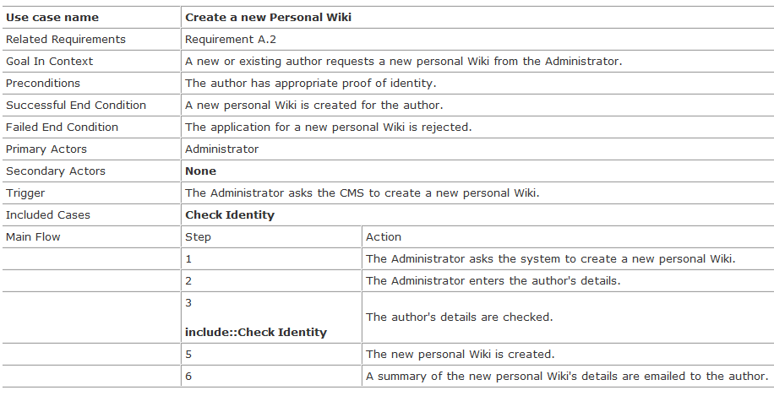

Development Path: (List of potential APIs, tools, programming environment, software etc. to be used in implementation)

References (if applicable, make a bulleted list):

